**Installation Guide**

The zipped folder should be unzipped.

**Java Application**

1. Open IntelliJ IDEA.
2. Click File / Open…

1. Look for the following directory inside of the unzipped folder and open it as an IntelliJ Project:

*APPENDICES\APPENDIX FOLDER 4 - SOURCE CODE\SEP1Ygroup6*

1. After having opened it, click File / Project Structure…

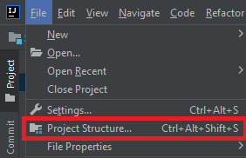

1. Go to Global Libraries, press the “+” sign and click “Java”.

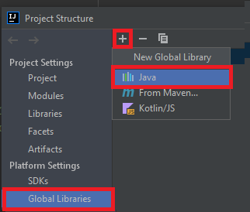

1. To import XmlJsonParser, go to the directory: *APPENDICES\APPENDIX FOLDER 4 - SOURCE CODE\EXTERNAL JAR FILES* and select **XmlJsonParser-1.4.jar**Text

   Description automatically generated
2. To import JavaFX 11, go to the directory *APPENDICES\APPENDIX FOLDER 4 - SOURCE CODE\EXTERNAL JAR FILES\javafx-sdk-11.0.2\lib* and select all of the .jar files

Now, the project has been opened in IntelliJ and the external .jars have been imported.

1. External .txt files should be placed inside of the following directory:

*APPENDICES\APPENDIX FOLDER 4 - SOURCE CODE\SEP1Ygroup6\src*

NOTE: The directory also has an empty file called “INSERT TXT FILES IN THIS DIRECTORY”.

NOTE: The folder includes the default “.txt” files given at the beginning of the Project Period. It is okay to overwrite them.

1. To run the program, look for the Main class and run it.

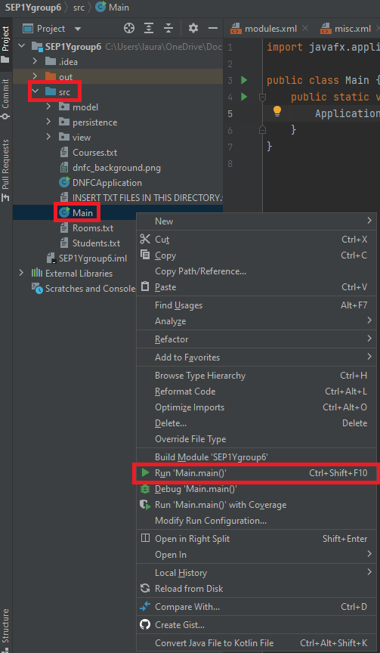

1. Enjoy your scheduling :)

**Website**

1. Open Visual Studio Code.
2. Press File / Open Folder… Graphical user interface, text, application

   Description automatically generated
3. Open the directory *APPENDICES\APPENDIX FOLDER 4 - SOURCE CODE* and choose the folder called *website*. 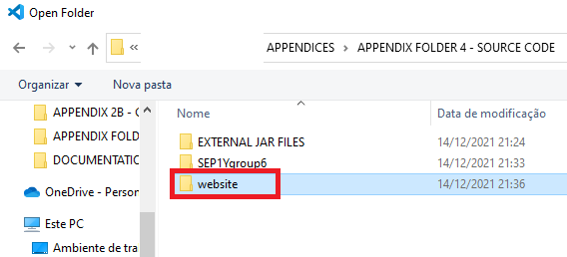
4. VERY IMPORTANT: open the website with Live Server. Text

   Description automatically generated
5. If you do not have Live Server, go to “Extensions” on the left, look for it and install it. Then, go back to step 4.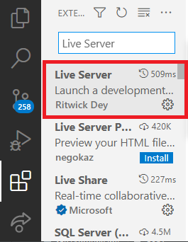
6. Enjoy timetables! :) Chart

   Description automatically generated with medium confidence